# **ANNUAL EXAMINATION - 2077**

**Grade: IX Full Marks: 50**

**Subject: Science Pass Marks: 20**

**Time: 1 hour and 30 minutes**

**Group A: Short Question Answers. [10 * 1 = 10]**

* 1. Write the SI unit of intensity of light and temperature.
  2. Define one Newton force.
  3. How much work does an electric bulb rated 40watt do in one second?
  4. Mention a difference between N2 and 2N?
  5. The solubility of copper sulphate at30⁰C is 24. What does it mean?
  6. Why virus is called obligatory parasite?
  7. Write the name of the longest and the smallest bone found in human body.
  8. Write two examples of nitrogen fertilizer.
  9. What is sugar charcoal?
  10. Write the full form of IUPAC.

**Group B [10 * 2 = 20]**

* 1. Write two differences between fundamental unit and derived unit.
  2. How fast should a boy of mass 35kg run so that his kinetic energy will be 1400J?
  3. To lift a load of 200N by using two pulley system 150N effort is necessary. Calculate the efficiency of the simple machine.
  4. Draw a well labelled diagram of refraction of light through a glass slab.
  5. Write down the molecular formula of calcium chloride and aluminum chloride by crisscross method.
  6. Write any four uses of water.
  7. What is the role of decomposer in an ecosystem?
  8. Plants do not grow tall when their tip are cut, why?
  9. Draw a molecular structure of O2(oxygen).

**Group C [4 * 3 = 12]**

* 1. State Newton’s second law of motion and prove that F=m×a.
  2. Define one joule energy. In a wheel and axle, diameter of wheel is 100cm and radius of axle is 0.1m. If its MA is 2 then calculate its VR.
  3. Draw a neat and labelled diagram of human eye.
  4. Write down one function of meristematic tissue, epithelial tissue and xylem each.

**Group D [4 * 2 = 8]**

* 1. How can we remove permanent hardness of water? Write along with chemical equation involved.

Or

Study the given figure and calculate:

* + 1. 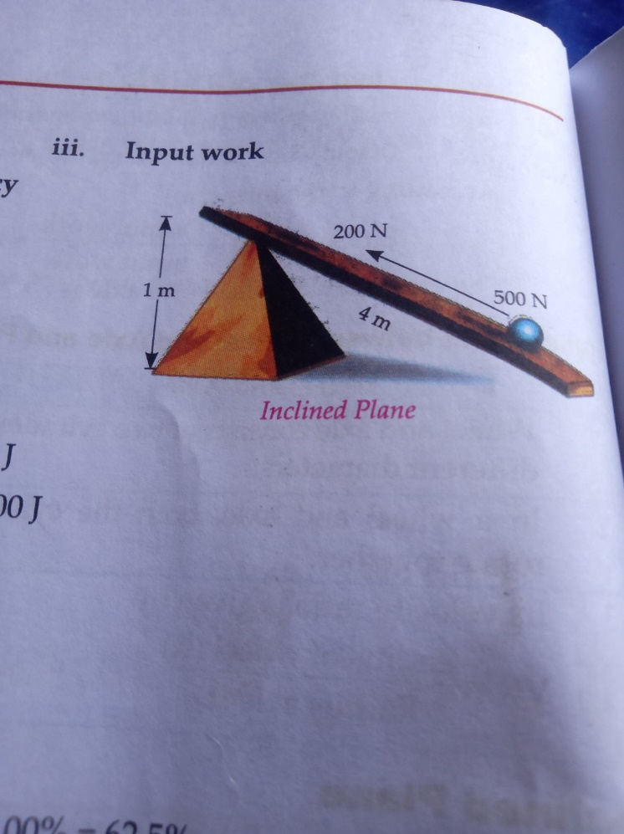MA
    2. VR
    3. Input work
    4. Output work
    5. Efficiency
  1. Draw a neat picture of bacteriophage virus. Write any two useful and two harmful effects of bacteria.

*Best Wishes!!!*